Global Testing Practice

Selenium-BDD Test Automation Framework
– User Manual

Project Name:
Amendment History - Document Status (e.g. Draft, Final, Release #):
CR# (optional) | Document Version# | Approval Date | Modified By | Section, Page(s) and Text Revised
 | 1.1 | NA | Dhiraj Kumar Sharma N | BDD-Updates

Glossary of Acronyms
ACRONYM | FULL LENGTH
BDD | Behavior/Business Driven Development
Javac | Java Compiler
TDD | Test Driven Development
OR | Object Repository
POM | Page Object Model

Table of Contents
Use F9 to update the TOC

1 Objective 5
2 High level design features 5
3 Supported Environment 6
4 Supported Modes of Automated Script execution 6
5 Architecture 6
6 Procedure for Installing the Framework 7
7 Folder Structure and Components 7
8 Library of Utility Functions 12
9 Procedure for Developing Automated Test Scripts 13
10 Procedure for Configuring Test Environment 14
11 Procedure for Executing Automated Test Scripts 15
12 Known Limitations 17
13 Acknowledgement 17

Objective

Functional Test Automation, much as it is essential for achieving higher Test coverage and improved Test execution productivity on any project has its own challenges that are derived from but not limited to the following
- The type of application (Web based)
- The technology used to develop the application (Java)
- The platform used to host the application (Windows)
- The complexity of the business functionality and its User interface design

In a scenario where the inputs/requirements for any Test Automation project are varied, the need of the hour is to develop a “Utility Framework” that can accommodate these varying inputs/requirements and additionally provide the following benefits
- A consistent architecture for the Open Source automation tool.
- A consistent approach to develop the automated solution specific to each Test Automation project.
- Improved Test script development productivity
- Reusable Utility functions that can be consistently used across Web technology supported by the Tool. In future it will support Appium.

Selenium is the primary tool of choice for implementing Test Automation on all projects in future, unless the client has a specific preference to use tools from other vendors.

With this in focus, the Test Automation sub-capability has worked on developing a Generic Utility framework using Selenium tool.

The objective of this document is to provide the details of the different components of the Generic Utility Framework that is a core part of the Organizational strategy in establishing consistency in the way the Functional Test Automation projects would be executed across Testing Service Line.

To enable end users to understand and use the framework, this document details the way the Framework supports the development, maintenance and execution of the automated test scripts. In addition to this, the document also provides the necessary details related to configuration of the framework as well as the way to create and use external data sources for enabling creation of automated test scripts using the Data driven or Keyword driven approaches.

High level design features

The framework developed using Selenium has the following features

- For all Selenium supported technologies, this Framework

- Provides a consistent approach for developing automated test scripts for applications that are Web based.

- Provides a Library of technology independent reusable Utility functions. (Same functions can be used to automate applications developed using Java for Web based application.)

- Supports creation of automated scripts using Hybrid Driven approaches.

- Enables increased test script development productivity on a project as it provides reusable architecture and code.

- Provides end users with the means to execute scripts via XML based or via an Excel based interface.

- Provides the end users the feature of randomly selecting the required Test data rows from external Test data sources.

- Provides a folder structure to logically group the required Test Automation artifacts on local systems where the automated scripts are to be executed.

Supported Environment
- Test Management Tool : Jenkins
- Test Automation Tool : Selenium version 3.9 or higher
- Supported Operating Systems: Windows Operating System
- Supported Browsers: All Selenium supported browsers (like Internet Explorer, Google Chrome, Firefox, Opera and Safari etc.…)

Supported Modes of Automated Script execution

- The framework supports execution of automated test scripts from the Data Driven module via creation of Test sets.
- In an integrated environment, the framework supports execution of automated test scripts via Jenkins.

Architecture
BDD – Framework

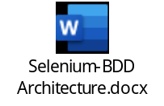

Procedure for Installing the Framework
Installing the framework is simple, Download the project from the git Repository to your Local Eclipse IDE and Build it through Maven.
On Mavenizing the project All the dependencies are automatically downloaded into the Repository
Updating the “Config.properties” file
- In the “Config.properties” file available in “Test_Configuration” folder, update the value tag of the tag PROJECT_FOLDER_PATH with the absolute path of the folder under which the framework artifacts are installed on the local system.
If the testing of Web applications is carried out on multiple browsers, update the “BrowserName” tag with the values corresponding to different browsers as shown below.
- When testing has to be done on Internet Explorer browser, the value should be “InternetExplorer
- When testing has to be done on Mozilla Firefox browser, the value should be “MozillaFirefox”
- When testing has to be done on Chrome browser, the value should be “Chrome”

Folder Structure and Components

To logically group all the Utility Framework artifacts, the following folder structure is used on a local system where the execution of the automated scripts is carried out.

This group of folders will be created when the installation of the framework is completed.

POM Approach - Folder Structure

**********************************************************************************************************
[Project_Name]

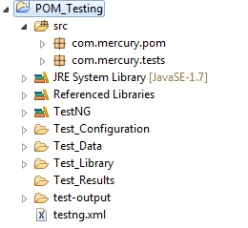
***********************************************************************************************************
BDD Approach - Folder Structure

***********************************************************************************************************
[Project_Name]
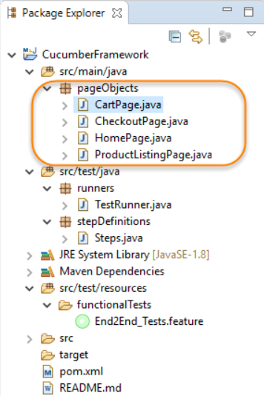
Details of each folder

[Project_Name]:

This is the main folder under which all the artifacts used for the Utility Framework Automation project are stored. To uniquely distinguish the artifacts across different projects, it is suggested that the main folder is given the name that has a reference to the project name/ID.

Test_Configuration

In this sub folder, the file named ““Config.properties” that stores the Test environment variables and their corresponding values is stored by default. New variables can be added as required in this file.

When the keyword driven approach is used, the KeywordDriven_FunctionReferences.xls file that contains a mapping of the Keyword driven functions and the library files in which they are stored will also be updated and stored in this folder.

Test_Data

In this sub folder, the external Test data source files are stored. The test data files should be created by using the template “Test_Data_Source_Template.xls” that is stored in the “Test_Templates” folder. Multiple data files and each file containing multiple test data tables can be created and stored in logically related sub-folders in this folder.

Test_Libraries

In this sub folder, the following files are available.
- Selenium Standalone Jar: Selenium standalone jar file named “selenium-server-standalone-x.yz.jar” where x. yz represents version of the required standalone file.

- External Jars: External jar files which are required for the automation like Apache Poi are available under this folder

Refer the section “Library of utility Functions” for more details on the existing functions in the library file.

Test_ObjectRepositoy

There are two approaches with which user can store the test Objects.

Keyword Driven Approach:

In this sub folder, OR.properties file that contains the Test Object Properties of all Test objects that are referenced in automated scripts, are stored.

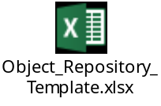

POM Approach:

User can define their test objects inside script level also, like in the test data section of POM (Page Object Model) class. In this approach there will not be an OR.properties files under Test_ObjectRepository folder.

Functional Tests/Feature Package: A feature usually contains a list of scenarios to be tested for that feature. A file in which we store features, description about the features and scenarios to be tested is known as Feature File. There should be a separate feature file, for each feature under test. The extension of the feature file needs to be “.feature”. One can create as many feature files as needed. To have an organized structure, each feature should have one feature file.

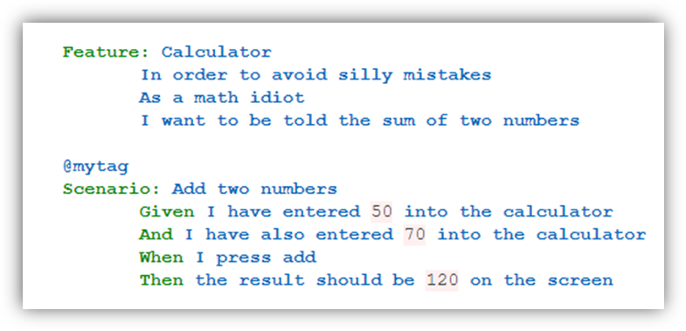

Step Definitions: Step Definition file. Steps definition file stores the mapping between each step of the scenario defined in the feature file with a code of function to be executed. So, now when Cucumber executes a step of the scenario mentioned in the feature file, it scans the step definition file and figures out which function is to be called.
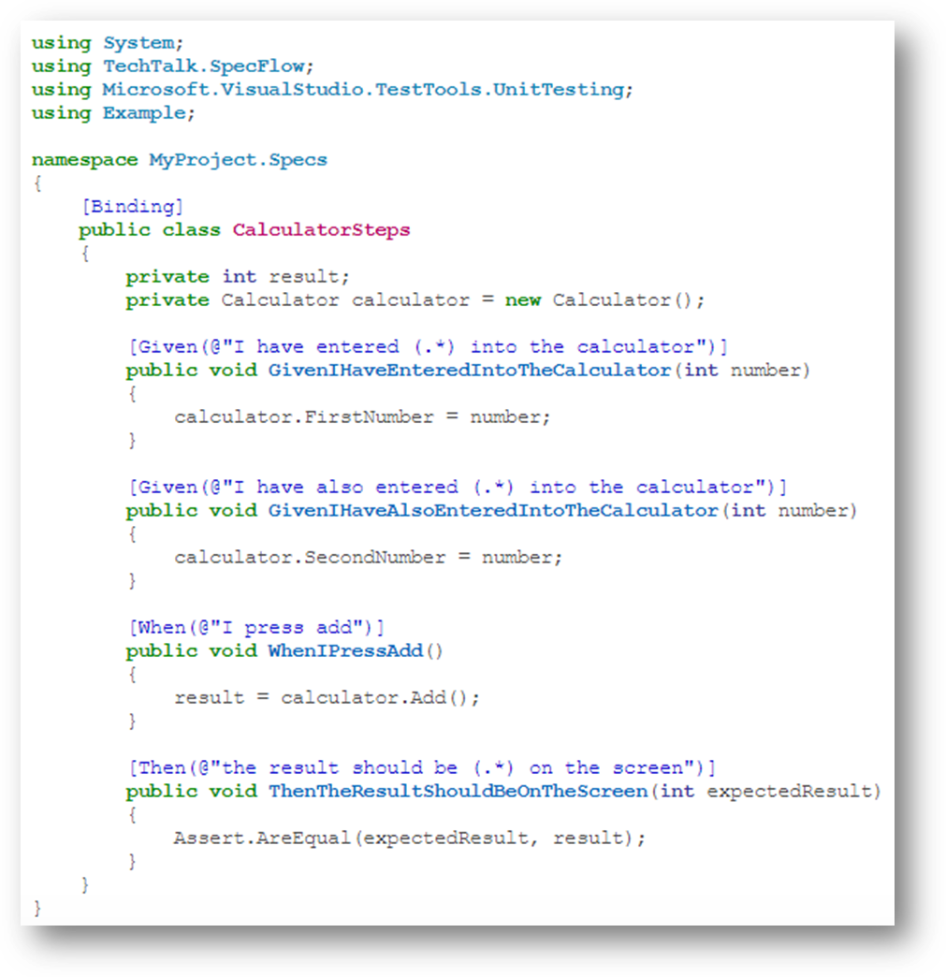
Runner Package: Cucumber test runner class is one of the many mechanisms using which you can run Cucumber feature file. It also acts as an interlink between feature files and step definition classes. It is in test runner class, that you provide the path for both feature file and step definition class.

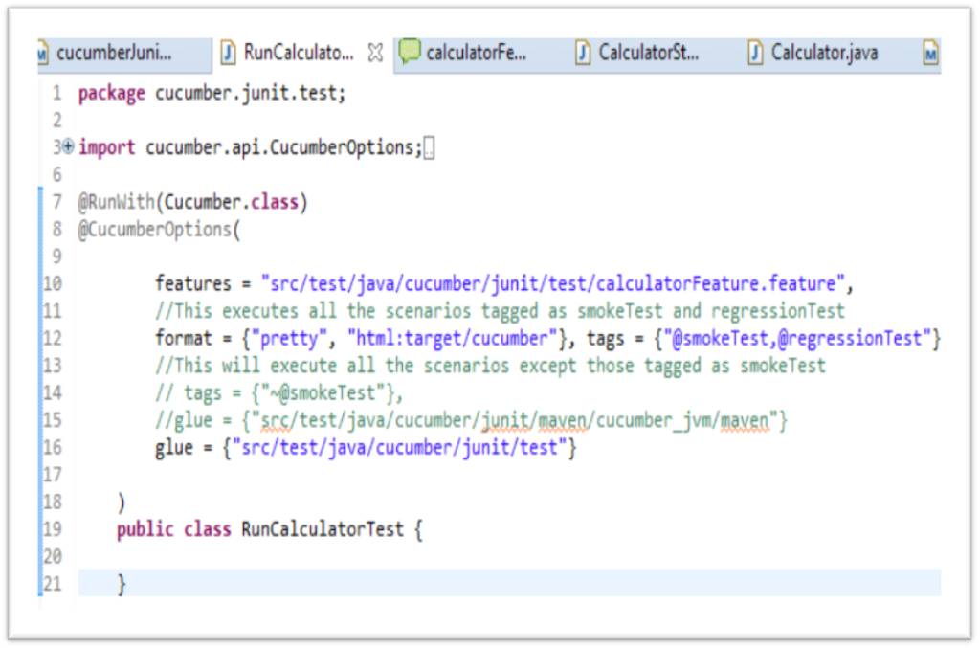

Test_Results

Result file contains the details of all execution steps for the selected automated scripts will be stored in this folder with the name corresponding to the date-timestamp when the execution was initiated. Refer the section “Procedure for Executing Automated Test Scripts” for more details.

POM Package:

In the POM approach, Test Scripts are created using the Selenium based Test script template that is available in the “Test_Templates” folder.

It is mandatory to store the logically related test scripts belonging to a module in the application under corresponding sub-folders and store the corresponding automated test scripts in these sub-folder.

For Ex: If the application has modules named “Admin”, “Reports” etc and for each of these modules there are multiple test cases that are to be automated, then in the “Test_Scripts” folder create sub-folders named “Admin” and “Module” (or any name as per conventions defined in the project) and store the correspondingly related automated scripts in the “Admin” and “Reports” sub-folders.

Note: Sample scripts created using POM and Keyword driven templates are also shown in this folder.

Test Templates

In this sub-folder, the following templates are provided.

- Test_Data_Source_Template.xls: This template is used for creating the required test data tables for either the keyword driven or data driven test scripts. Please refer the “Instructions” worksheet” for more details.

Also note that we can create multiple test data files and each file can have multiple test data tables.

It is recommended to store the project specific data files in logically named sub-folders in the “Test_Data” folder (similar to the recommended way for storing automated scripts in the “Test_Scripts” folder).

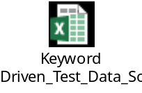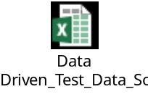

- KeywordDriven_FunctionReferences_Template: This template is used for mapping the Keyword driven functions and the library files in which they are stored. This file should be renamed to “KeywordDriven_FunctionReferences.xls” and stored in the “Test_Configuration” folder.
Note: This template is used only in the Keyword driven approach. Please refer the “Instructions” worksheet” for more details.

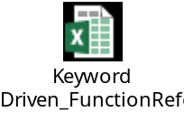
Test Documentation

In this folder any documentation relevant to the Utility framework can be placed. The documents placed in this folder will not impact the execution of the automated scripts in any way.

Library of Utility Functions

The Utility functions file present in the “Test_Libraries” folder are the building blocks for developing the application specific business functions as well as the automated test scripts using either the Keyword driven or Data driven approaches.

It is mandatory that the details of the functions be understood before using them in developing the automated test scripts.

The feature of these Utility functions is that they can be used for developing automated test scripts for testing functionality of Web based applications. Additionally, these functions can be used for developing automated scripts irrespective of whether the application is developed using Java or .NET or Python or Ruby or any other Selenium supported platforms.

Hence a great deal of reusability (across technologies or application types) is imbibed in these Utility functions.

The utility functions in framework can be categorized into:
  - Common functions for automation of Web-based applications
  - Functions for use in the keyword-driven approach only
  - Framework support functions

Common functions for automation of Web-based Application

The table below lists some Utility functions that can be used for performing tasks/validations in Web based applications. These functions can be used for developing automated scripts for testing applications that are Web based applications.

Function Name | Information on usage
readConfigurationFile | Used to read the configuration file from the specified location.
enValueInEditField | Used to enter web element values in specified locations in Edit or Text fields of a GUI.
clickElement | Used on components that support the Click operation (push buttons, links, and images). Performs a click operation on the specified web element.
selectChkBox | Used to select or deselect a check box for specified web element.
selectRadButton | Used to select a radio button.
selectItemFromListBoxByValue | Used to select a specified value from a list of values in a drop-down list box.
waitForElementVisibility | Used to wait the application until the element is visible in the page
captureScreenShot | Used to Capture the screenshot of the entire screen.
closeBrowsers | Used to close the browser that is being tested.

Functions used in Keyword driven approach only

The framework supports developing automated scripts using the data driven or keyword driven approaches. The list of functions in the table below are specific only to the Keyword driven approach for developing automated scripts using the framework.

Function Name | Information on usage
enValueInEditField | Used to enter string values in specified object location in Edit or Text fields of a GUI.
clickElement | Used on components that support the Click operation (push buttons, links, and images). Performs a click operation on the specified object.
selectChkBox | Used to select or deselect a check box for specified object.
selectItemFromListBoxByText | Used to select a specified value from a list of values in a drop-down list box by text.
waitForElementInvisibility | Used to wait the application until the element is masked in the page
captureObjectLevelScreenShot | Used to Capture the screenshot of the specified object.

Framework support functions

The following list of functions are used for developing the core logic in the framework and are not meant to be included (by function calls) directly in the automated test scripts that are developed.

Function Name | Information on usage
readConfigurationFile | Used to read the configuration file from the specified location.
generateRandomNumber | Used to generate the random numbers.
Please refer the inserted document for a listing of all Utility functions that are used in the Framework.
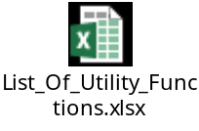

Procedure for Developing Automated Test Scripts
Pre-requisites:

- Selenium version 2.53 or any higher version of the tool should be used.
- Any specific add-in required for the test should also be loaded on the system where Selenium is installed.
- Create page object model class.
- The required Object repositories should have been created and stored in the “Test_ObjectRepository” folder [OR.properties file Or POM class].
- The required Test data sources containing test data tables should have been created and stored in the “Test_Data” folder by following the instructions specified in the “TestData.xls” file.

Developing test scripts

Handling Feature name on the start of the test in Test Case Listener class and Scenario name in Before Tag of the Hook class

@Override
public void onStart(ITestContext arg0) {
extent=setUp();
Feature = extent.createTest(Feature.class, StepDefObj.FeatureName);
CreateExcelReport();
}

@Before
public Object beforeScenario(Scenario s) {
scenario=s.getName();
String BrowserName = UtilityFunctions.readConfigurationFile("BrowserName");
utilityFunction.initilizeDriver(BrowserName);
return scenario;
}

Procedure for Configuring Test Environment

The following mentioned steps are mandatory to setup the Test environment.

- Java 8 or higher version should be installed in the user machine in order to work with Selenium.

- User should be download and install the Eclipse IDE in the machine.

- Install the Firebug add-on for the Firefox browser in order to inspect the web element in Firefox browser.
Steps to install Firebug add-on.
- Open Mozilla Firefox and click on “Add-ons” icon at the bottom of the browser.
- Go to the Search box and type Firebug and then select Firebug and hit the Install button.
- After hit the Install button it will download the Firebug and ask to you for restarting the browser.
- Restart your Mozilla Firefox.
- To see the Firebug panel press F12 button.

Note: Google Chrome and IE has its own developer tool that can be used to identify and locate web elements on the web page. Press F12 to launch the tool.

- Install FirePath add-on for Firefox browser in order to check whether written XPATH for the inspected element is valid or not in Firefox browser.
Steps to install FirePath add-on.
- Open Mozilla Firefox and click on “Add-ons” icon at the bottom of the browser.
- Go to the Search box and type FirePath and then select FirePath and hit the Install button.
- After hit the Install button it will download the Firebug and ask to you for restarting the browser.
- Restart the Mozilla Firefox.

- Install the TESTNG in the end user system.
Steps to install TESTNG in the system.
- Launch the Eclipse IDE and from Help menu, click “Eclipse MarketPlace”.
- Type the TestNG string in Find dialogue box and press Enter.
- Click on Install button displayed in “TestNG for Eclipse” page.
- Select TestNG (required) checkbox and click on Confirm button.
- Select the “I accept the terms of the license agreement” radio button in Review Licenses window and click “Finish” button.
- PATH (JAVA_HOME) environment variable should be point to the latest version of the JDK bin path in the machine. Advantage of setting this variable is user can able to run the executables (javac, java, Javadoc, and so on) from any directory without having to type the full path of the command.

Steps to set the PATH environment variable in the system.
- From the desktop, right click the Computer icon.
- Choose Properties from the context menu.
- Click the Advanced system settings link.
- Click Environment Variables.In the section System Variables, find the PATH environment variable and select it. Click Edit. If the PATH environment variable does not exist, click New.
- In the Edit System Variable (or New System Variable) window, specify the value of the PATH environment variable. Click OK. Close all remaining windows by clicking OK.

- Config.properties: This is the default file that is present in Test_Configuration folder in the environment. It is mandatory that the required variables available in the property file be updated with the values specific to the environment defined for the project irrespective of whether the Data driven, or keyword driven approach is used for developing the automated scripts.

- External Jar files which are required for the project are placed inside the Test_Libraries folder. Example: Apache poi jar files for excel interaction with the scripts.

j) KeywordDriven_FunctionReferences_Template.xls: This template, available in the “Test_Templates” folder, is used only in the scenario where the Keyword driven approach (as per the procedure in the framework) is followed for developing the required business functions for use in the Keyword driven scripts.

It is mandatory that all the Keyword driven functions that have been created for use in the keyword driven scripts be referenced in the “KeywordDriven_FunctionReferences.xls” file. Else there will be runtime error as the Action file driver script will not be able to locate and execute the steps of the corresponding keyword driven business function.

Procedure for Executing Automated Test Scripts
Please contact Dhiraj Kumar Sharma N, to get the procedure for executing automation test scripts for POM Approach.
Keyword Driven Approach
If you are going for a Keyword driven Approach follow the below steps.
- Open Eclipse.
- Go to file menu.
- Click “Import” navigate to “General”.
- Click “Existing Project into Workspace”
- Click “Next”.
- Click on “Browse” select the keyword driven framework from your package directory, click on “OK”.
- Click on “Finish”.
- In your package explorer you will see the keyword driven framework project. Right click on that project go to build path.
- Choose the configured build path from dropdown list.
- Under the library tab, many libraries will be listed out.
- Except “JRE System Library” & “TestNG” library remove all other libraries.
- Click on “Add Jars”, then under your project you will find “Test_Kewyord_Library” folder, from here add all the jar files.
- Now the project is ready to use.
- Under “Test_Files”, two excel files will be seen [Object Repository & TestData]
- In “TestData” file all the test data will be present in the specified layout.
- In “Object Repository” file, user has to mention the object & its value. The value is a combination of two parameters separated by a pipeline. [First Parameter: PropertyName, Second Parameter: Property Value e.g. xpath|.//*[@id=’userName’]
- Once the TestData & ObjectRepository files are ready, then Right Click on TestNG.xml and then Goto “Run As”, from “Run As” select “Run As TestNG”.
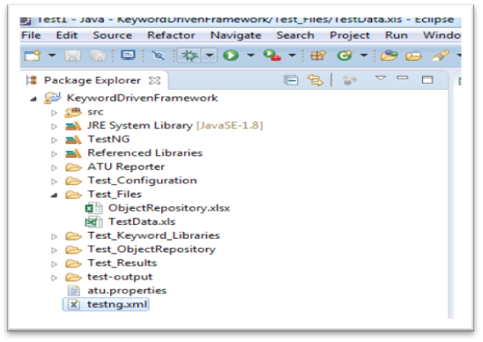

Known Limitations
- This Framework supports only web-based applications.
- This Framework is compatible only on Windows Operating System.
- Automation of authentication using access card, Biometric scanners, SMS verifications, Payment through card swiping cannot be done.
- Framework does not support file upload facility. Third party tool needs to be used for this functionality.
- Framework need outside support for report generation activity like dependence on TestNG or Jenkins.
- Text present in the images cannot be compared.
- Cannot execute the script on already existing browser.

Acknowledgement

The following resources have contributed to the design and development of the framework.

- Dhiraj Kumar Sharma

